ASSIGNMENT 1

**SMART HOME**

Submitted by,  
 Aiswarya.S  
 960219106011

**Circuit Diagram:**

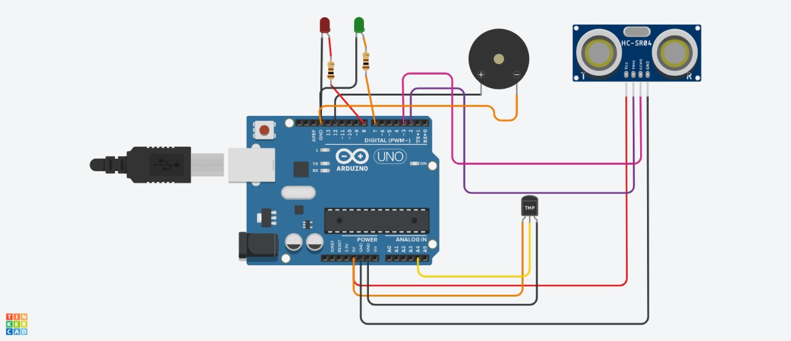

**Code:**

// C++ code

//

int a=2;int b=3;

void setup()

{

Serial.begin(9600);

pinMode(a,OUTPUT);

pinMode(b,INPUT);

pinMode(12,OUTPUT);

}

void loop()

{

//ultrasonic sensor

digitalWrite(a,LOW);

digitalWrite(a,HIGH);

delayMicroseconds(10);

digitalWrite(a,LOW);

float dur=pulseIn(b,HIGH);

float dis=(dur*0.0343)/2;

Serial.print("Distance is: ");

Serial.println(dis);

//LED ON

if(dis>=100)

{

digitalWrite(8,HIGH);

}

else

{

digitalWrite(8,LOW);

}

//Buzzer For ultrasonic Sensor

if(dis>=100)

{

digitalWrite(12,HIGH);

delay(500);

}

else

{

digitalWrite(12,LOW);

delay(500);

}

//Temperate Sensor

double a= analogRead(A4);

double t=(((a/1024)*5)-0.5)*100;

Serial.print("Temp Value: ");

Serial.println(a);

//LED ON

if(t>=100)

{

digitalWrite(7,HIGH);

}

else

{

digitalWrite(7,LOW);

}

//Buzzer for Temperature Sensor

if(t>=100)

{

digitalWrite(12,HIGH);

delay(500);

}

else{

digitalWrite(12,LOW);

delay(500);

}

}

**Tinkercad automation link-https://www.tinkercad.com/things/0XfMakkWlV0-grand-vihelmo/editel?sharecode=dtM-S4q3uRBNBjjoZm9yGVUBaYYlk_sT6PYdpXxrIeE**